Question 1
- (i) Find the discriminant of the quadratic expression 4x2 − 4x + 1.

Solution
4x²−4x+1=0
General quadratic equation is given by
ax² + bx + c = 0,

Thus a = 4, b= −4 and c= 1.
The discriminant (D) is given by;
D=b² −4ac
⇒D=(−4)² − 4⋅4⋅1
⇒D=16−16
⇒D=0

(ii) What does this tell you about the number of solutions of the equation? Explain your answer briefly.

Thus, the number of solutions is one

When discriminant is equal to 0, it means that there is only one real root.

(iii) What does this tell you about the graph of y = 4x² − 4x + 1?

Since the value of a>0 and D=0, then the graph of y = 4x² − 4x + 1
- touches x- axis,
- is above x-axis and
- it opens upward in the direction of + ve y-axis

- (i) Find the equation of the axis of symmetry of the parabola, explaining your method.

The midpoint of the horizontal line with coordinates (-2, 0) and (5, 0) is (3.5, 0)
The vertical line perpendicular to this at the midpoint is the axis of symmetry of the given parabola.

Its equation is x = 3.5

(ii) Use your answer to part (b)(i) to find the coordinates of the vertex of the parabola.

At the point of intersection, both the equation of a parabola and that of symmetry line are equal.
Also, at the point of intersection, the value of x= 3.5

Since y = 3x² -9x – 30
Substituting the value of x in the above equation,
Y= 3 x 3.5² – 9 x 3.5 -30
Y = 36.75 – 31.5 – 30
Y = - 24.75.

Thus the coordinates of the vertex of a parabola is (3.5, - 24.75)

(c) This part of the question concerns the quadratic function
y = x ² − 12x − 22.

- Write the quadratic expression x ² − 12x − 22 in completed-square form.

Solution

The equation of complete square is given as
a² + 2ab + b² | = | (a + b)²

From x ² − 12x – 22=0, a=1 and 2b= -12.

x ² − 12x = 22

Adding the square of b in both sides we get,

x ² − 12x + 36 = 22 + 36
Thus (x - 6)²= 58
The compete square form of the equation is

y= (x - 6)² - 58

ii. Use the completed-square form from part (c)(i) to solve the equation x ² − 12x – 22=0, leaving your answer in exact (surd) form, simplified as far as possible.

Solution

From (x - 6)²= 58, the left hand side is a perfect square of (x-6)
This equation has the form
A²=B
This implies that
A= ±$\sqrt{B}$
Hence
x – 6 = ± $\sqrt{58}$
x = 6 ± $\sqrt{58}$

the conjugate values are: x = 6 + $\sqrt{58}$ ,
x = 6 - $\sqrt{58}$

iii. Use the completed-square form from part (c)(i) to write down the vertex of the parabola y = x2 − 12x − 22.

Solution
The complete square equation is: y= (x - 6)² - 58

From this, the vertex of the parabola is (6, - 58)
iv. Provide a sketch of the graph of the parabola y = x 2 − 12x − 22, either by hand or by using Graphplotter.

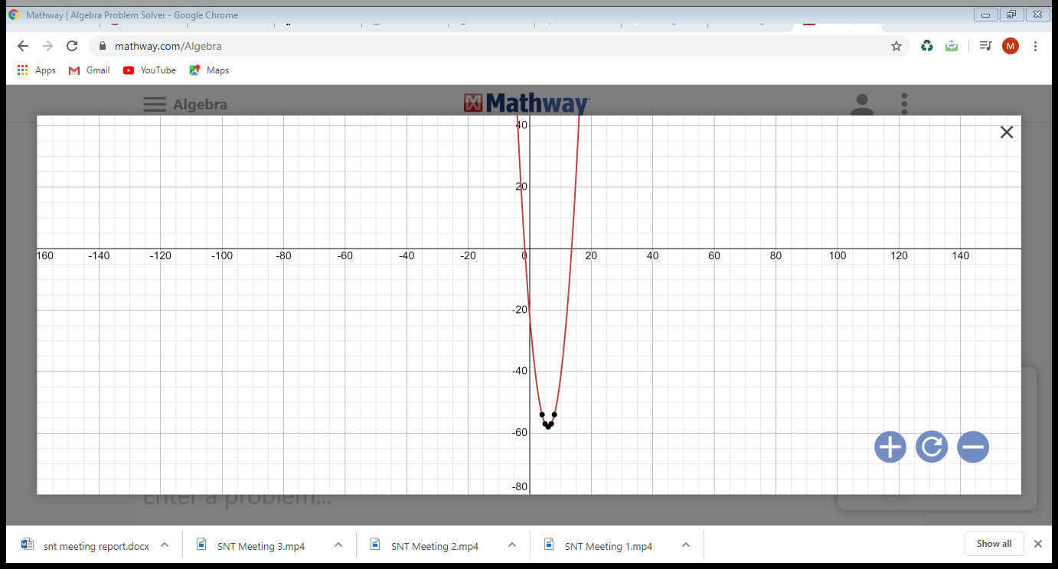

Question 2

- Hannah wants to check that her code is working correctly so she simulates a test golf swing for a driver. The quadratic equation generated by her code is
y = 0.0025x ² + 8.0227x + 0.0491.

By considering the coefficient of x², explain why Hannah’s code must contain an error.

- Hannah corrects the error, and runs the code again to simulate another test swing from a driver. This time the quadratic equation generated by the code is

y = −0.0016x 2 + 0.4801x + 0.0489.

In this part of the question, you are asked to consider the trajectory of the golf ball modelled by this equation. (The graph of y = −0.0016x 2 + 0.4801x + 0.0489 is a parabola.)
- Explain why the y-intercept is 0.0489.

The y-intercept is 0.0489 since at this point, the value of x=0

Thus y= -0 + 0 + 0.0489
y= 0.0489

- What does the y-intercept represent in the context of this model?

The y-intercept represent the height at which the golf ball is shot at.

- Use the quadratic formula to find the x-intercepts. Give your answers correct to four decimal places.

Solution

X = $\frac{-b± \sqrt{b^{2}-4ac} }{2a}$
= $\frac{-0.4801 ± \sqrt{{0.4801}^{2}-4 x -0.0016 x 0.0489} }{2 x -0.0016}$

= $\frac{-0.4801 ± 0.4804}{ -0.0032}$
X=300.1563 and
X=-0.0938
- In the simulation, the hole is 325 metres away from where the virtual golfer teed off. Explain why the golfer can’t possibly have scored a hole-in-one

The hole is far away from the position of X that the equation presents. The value of x is 300.1563 and the position of the hole is 325 meters.

- Hannah decides to add a tree which stands 10 metres tall to the virtual golf course. She positions it directly in the path of the test shot, at a distance of 270 metres horizontally from where the ball is struck. Will the golf ball clear the tree? Explain your answer.

Solution
In this case the value of x=270.
This means that when x is substituted in the equation, it should give the value of y=10. If it does not, then the golf ball will not clear the tree.

Thus,
y = −0.0016x ² + 0.4801x + 0.0489. x=270

= - 0.0016 x 270 ² + 0.4801 x 270 + 0.0489

= 13.0359
The virtual golfer will not clear the tree since 10m $≠$ 13.0359m

Question 3
- Jakub considers displaying the data as a dotplot. Do you think this would be a good choice for representing this data? Give a reason for your answer.

No. Dot plots is suitable for a data with small numbers of values. It may not work well for this data but histograms of box plot may.

3 Ways to improve the clarity of boxplots.
- Choosing suitable scale helps accommodation of more data and minimizes outliers.
- The two boxplots should be drawn adjacent to each other for ease of comparison.
- The lower quartile, median and upper quartile vertical marks should be bolded because they provide reference during analysis.
One way that can help to identify a box plot with respect to the data it present.
When box plots are used to represent two raw data, the boxes can exhibits some similarities but the easiest way to identify the box is checking the median from the raw data and then correlating this value with the median shown in the boxplot.
On average, class A performed better than class B.
Correct.
The two medians for class A and class B are close to each other i.e 62 and 65 are adjacent in the box. Since the whiskers for box B have extended more toward the lower quartile compared to box A this mean that more students performed below the median value (65) in class B contrary to class A where number of students who scored below median value(62) is less. The box is skewed to the right for class A which indicates that most students scored above median value.

‘There was more variability in the marks from Class B than from Class A.
Correct.
The length of the box indicates interquartile range. Since boxplot that represents class B is longer than that of A, this definitely indicates the variability of marks that are within the lower and upper quartiles. Of course the number of outliers is equal for both cases, therefore this interpretation is correct.
‘In Class A, more students scored less than the median mark than scored greater than the median mark.
Incorrect.
The number of students in the either side of the median mark is represented by the extension of the whiskers. In the case of boxplot A, the whiskers have extended more toward the upper quartile than the lower quartile. Consequently, there were more students who performed well and scored marks above the median value.
Symmetry or Skewness of boxplot B.
Boxplot B is not symmetrical about the median but rather skewed to the left. It is clear that the median does not divide the box into two identical parts because the left side is longer than the right side. This indicates that more data was dispersed between the lower quartile and the median. In other words, the boxplot is skewed to the left.
Which histogram belong to class A?
Figure 4 represents class A.
This is simply because the lowest value in class A is not zero and thus the graph does not start from the origin.

One aspect of the performance of the two classes that can be seen more easily on the histograms than on the boxplots.
The frequency of data can be easily noted. For instance, the number of students who scored marks within the same interval can be easily scribbled down.
One aspect of the performance of the two classes that can be seen more easily on the boxplots than on the histograms.
The overall average performance is clearer in the box plot than in the histogram. With the aid of the boxplot, it is easy to tell whether most students scored below or above median value. In the case of histogram, this data can only be obtained after computation of the frequencies values which would consume time.

Question 4
(a). Figure 5 shows a sketch of a triangle, where all side lengths are measured in centimetres. Find the length of the side marked x, giving your answer correct to the nearest centimetre.

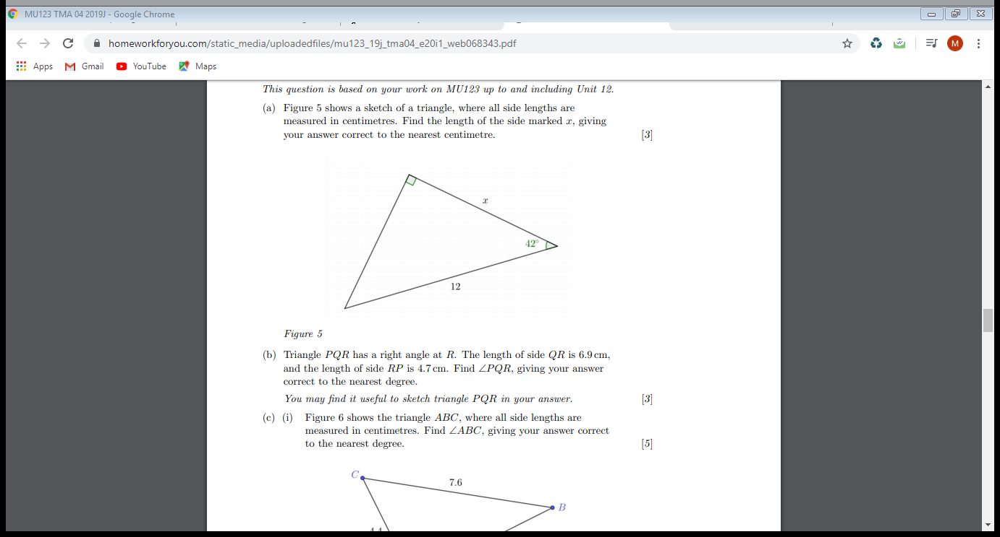

Solution

Applying SOHCAHTOA approach,

H=12
$θ$= 42

In this case Adjacent is x.

Cos $θ$ = $\frac{x}{H}$

Cos $42$ = $\frac{x}{12}$

x= 12 Cos $42$

= 8.9177
$≈$ 9.0 cm

b. Triangle P QR has a right angle at R. The length of side QR is 6.9 cm, and the length of side RP is 4.7 cm. Find ∠P QR, giving your answer correct to the nearest degree. You may find it useful to sketch triangle P QR in your answer

solution

P

4.7 cm
6.9 cm
Q
R

Angle PQR?
Using Tan $θ$ = $\frac{O}{A}$ = $\frac{PR}{QR}$ = $\frac{4.7}{6.9}$

$θ$ = Tan ⁻¹ ($\frac{4.7}{6.9}$)

$θ$ = 34.26
$≈$ 34º
(c). (i) Figure 6 shows the triangle ABC, where all side lengths are measured in centimetres. Find ∠ABC, giving your answer correct to the nearest degree.
Solution

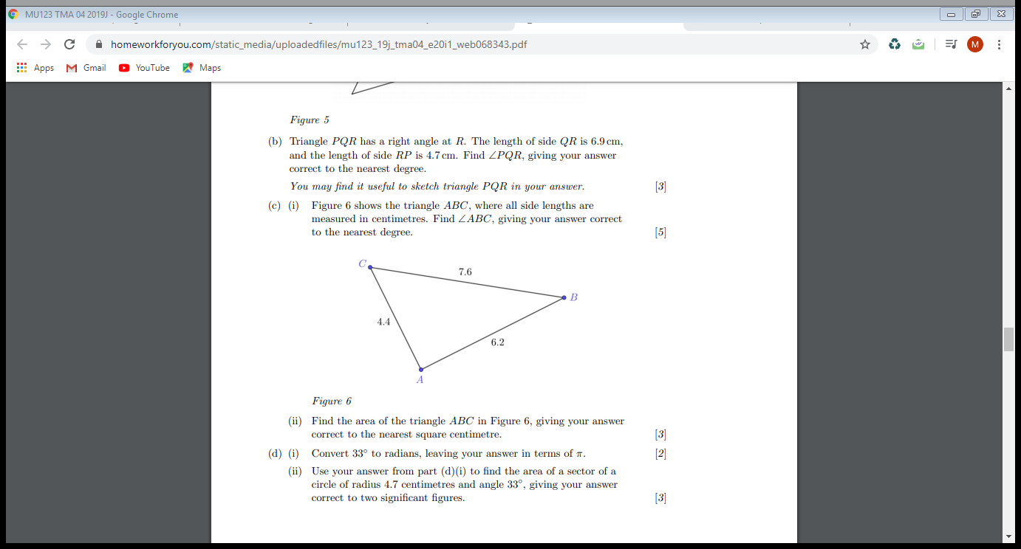

Applying Cosine rule,
a
C
B

b
c

A

b²=a² + c² – 2acCos B
Cos B = $\frac{ a^{2}+ c^{2}- b^{2}}{2 ac}$
Cos B = $\frac{ {7.6}^{2}+ {6.2}^{2}- {4.4}^{2}}{2 x7.6 x 6.2}$
Cos B = $\frac{76.84}{94.24}$
B= Cos ⁻¹ ($\frac{76.84}{94.24}$)
B= 35.3765 º
B $≈$ 35º
- Find the area of the triangle ABC in Figure 6, giving your answer correct to the nearest square centimetre.

Solution

Using Sine rule,

Area = $\frac{1}{2}$ ac Sin B
= $\frac{1}{2}$ x 7. 6 x 6.2 x Sin 35º
= 14 cm²
d). (i) Convert 33◦ to radians, leaving your answer in terms of π. [2]
Solution

1º= $\frac{π}{{180}^{o}}$

33º x $\frac{π}{{180}^{o}}$ = $\frac{11}{60}$π

- Use your answer from part (d)(i) to find the area of a sector of a circle of radius 4.7 centimetres and angle 33◦, giving your answer correct to two significant figures.

Solution
Area = π r²$x \frac{\frac{11}{60}π}{2π}$
= π x 4.7²$x \frac{\frac{11}{60}π}{2π}$
= 6.36 cm²
Question 5
- Caitlin would like to sketch a diagram of the situation, using A to represent the position of Transmitter A, B for the position of Transmitter B, and C for the position of Caitlin herself. Sketch a diagram showing the points A, B and C, marking in the angle and the lengths that you are given. Join the three points with line segments to make the triangle ABC.

Solution

5km
B
A
56º
C
2km

- Caitlin would like to calculate the distance between herself and Transmitter B. She realises that in triangle ABC she has two side lengths and an angle. She erroneously concludes that she can solve her problem with a single direct application of the Cosine Rule. Explain, as if directly to Caitlin, why she can’t use the Cosine Rule directly to solve her problem.

Caitlin may not be in a position to get the distance between herself and Transmitter B since she does not have the value of angle at Transmitter A.

- (i) Use the Sine Rule to find the angle at B. Give your answer correct to the nearest degree. [3]

Solution

Sine rule:
$\frac{Sin A}{a}$ = $\frac{Sin B}{b}$ = $\frac{Sin C}{c}$

In this case the value of c= 5km and b= 2km and angle C= 56º
Thus from the above equation,

Sin B = $\frac{Sin C}{c}$ x b
= $\frac{Sin 56}{5}$ x 2
B = Sin ⁻¹{$\frac{Sin 56}{5}$ x 2}
B= 19º

(ii) Use your answer to part (c)(i) to find the angle at A. Give your answer correct to the nearest degree. [1]

solution
Angle at A = 180º – (56º + 19º)
A= 105º

- Use the Cosine Rule and your answer to part (c)(ii) to find the distance between Caitlin and Transmitter B. Give your answer correct to one decimal place.

Solution
Let the distance between C and B = a
$\frac{Sin A}{a}$ = $\frac{Sin C}{c}$
a= Sin A x $\frac{c}{Sin C}$

a= Sin 105 x $\frac{5}{Sin 56}$

a= 5.8 km
Question 6
- Using what you know about right-angled triangles, and without performing any calculations, explain how you know that the student’s answer for the length BC must be wrong.

From the student’s calculation, the length of hypotenuse is 1.93m while that of adjacent is 3m.
This is wrong, adjacent length can never be longer than hypotenuse length.

- There are two places in the student’s attempt where a mistake has been made. Identify these mistakes, and explain, as if directly to the student, why, for each mistake, their working is incorrect.

Solution

first mistake

When calculating for the BC,

Cos 50º = $\frac{adj}{hpt}$ = $\frac{3}{BC}$
To get BC, it should

BC = $\frac{3}{Cos 50}$ and not BC = 3 cos 50

Second mistake
When Calculating for the length AB
The length of BC and AC is not equal to 1.93m

- Do you think the student’s approach to solving the problem is the most efficient method? Give a reason for your answer.

The student approach is not the most efficient in solving the problem.
The reason being that the triangle CMB and CAM are right-angled triangle and therefore, there is no need of using cosine rule.

(d) Write out your own solution to the problem, explaining your working. [4]
Solution

Calculating the length BC

Cos 50º = $\frac{adj}{hpt}$ = $\frac{3}{BC}$

BC = $\frac{3}{Cos 50}$

So BC= 4.667

And the length of BC= 4.67 m (correct to 2 d.p)

Calculating the length AB

First we find the length MB

Using Tan $θ$ = $\frac{opp}{adj}$

Tan $50$º = $\frac{MB}{3}$

MB= 3 tan 50º
MB= 3.57526m

Since MB=MA, the length of AB = 3.57526 x 2
= 7.15m (correct to 2 d.p)

Since the conference table is 7m, the camera will be able to film the whole length of the table.

Question 7
- Choose one topic from MU123 that you think is relevant to your wider study interests. Explain why you think your chosen topic is particularly interesting and/or relevant to your future study plans.
If you don’t find any of the topics from MU123 interesting or relevant to your future study plans, then explain why.

My chosen topic is the one involving Sine and Cosine rule
I find this topic so relevant when determining the values of unknown angles and lengths of a triangle especially when the tringle is not right-angled triangle. This will greatly help me in future when handling similar cases, not only during my study, but also in real life situation.
- Do you feel confident in your chosen topic? If so, describe one step you could take to maintain your confidence in years to come. If not, describe one step you could take to help you work more confidently in that topic.

Yes, I feel confident in this topic.

One way in which I can maintaining my confidence in this topic is solve as many problems relating to it as I can so I do not forget it the concepts involved.

